Post 114/Market Center Coalition
August 3, 2020
Notes
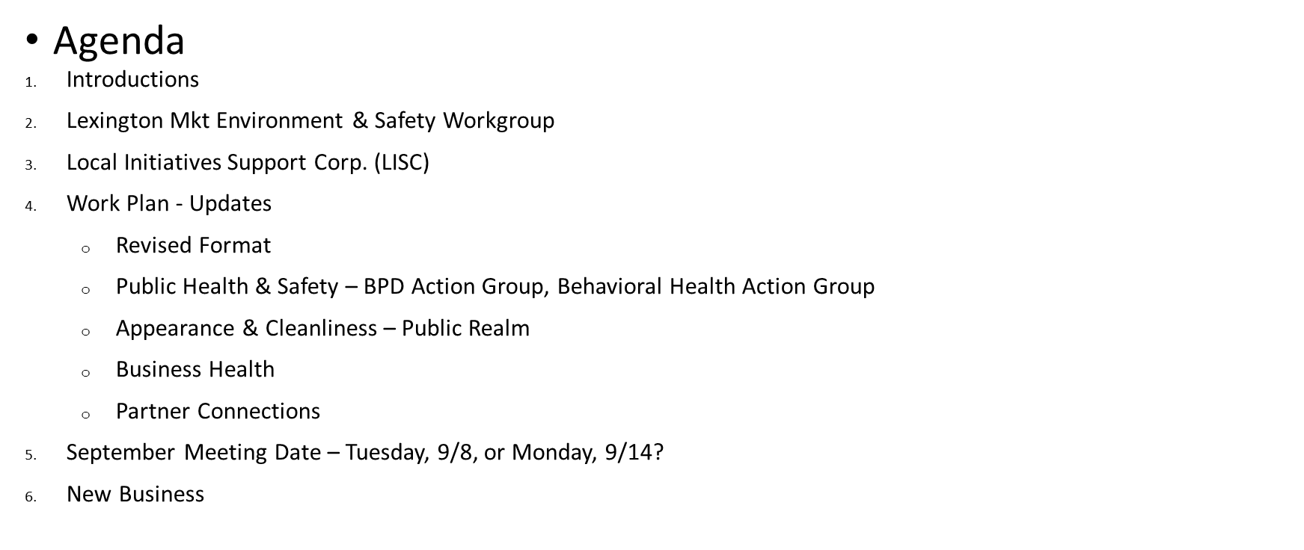

Attendance: Stephanie Bolton, DPOB; Rachelina Bonacci, MD Stadium Authority; Gwen Brown, BHSB; Scott Davis, Council President’s Office; Nate Fields, DPOB; Tamika Gauvin, MOCJ; Kevin Hayes, Councilman Costello’s Office; Shaffin Jetha, Focus Development; JR Jones, UMBPD; Judson Kerr, Southern Management, MCMA; Bill Marcus, DPOB; Kristen Mitchell, MCMA, MCCDC; Arish Narayen, BHSB; Marianne Navarro, Mayor’s Office; Stephanie Nichols, CRS; Larry Nunley, DPW; Bruce Panczner, Paradise Management, BEAM, MCCDC; Pickett Slater Harrington, Seawall; Perry Standfield, DPOB; Wanda Watts, Consent Decree Monitoring Team; Mike Watson, Everyman Theatre, MCMA; Kyree West, BDC
Lexington Market Environment & Safety Workgroup: Pickett Slater Harrington (PSH) reported that the new Market is expected to open in late 2021 or early 2022. The vendor application will be available on August 11. The goals of the Post 114/MC Coalition overlap with the goals of the Transform Lexington Market Environment & Safety Workgroup – addressing opioid dealing and addiction, appearance and cleanliness, and the health of surrounding businesses. Therefore, the two groups are blending their efforts to reduce the number of meetings dedicated to similar work and with similar participation.
LISC: The Local Initiatives Support Corporation is a national nonprofit with deep experience in working with communities to address Safety & Justice. For information about their Safety & Justice Initiative, visit https://lisc.org/our-initiatives/safety-justice/. The Mayor’s Office of Criminal Justice (MOCJ) has been speaking with LISC about Market Center and received a proposal from LISC to do some work in Market Center, which Tamika Gauvin will share with the group. LISC’s work would augment the Post 114/MC Coalition work, and MOCJ asked meeting participants for feedback. Bruce Panczner, Mike Watson, and Shaffin Jetha stated that they would not want to stop the momentum, but they are open to hearing about solutions and tools that have worked in similar communities. Tamika Gauvin will invite LISC to the October Post 114/MC Coalition meeting.
Connections: Perry Standfield recommended linking Wanda Watts, Tamika Gauvin, Pickett Slater Harrington, and Lindsey Eldridge (BPD Commissioner’s Office).
Consent Decree: Wanda Watts wants to know what we want to know about the Consent Decree, so she can be prepared to share information at the next Post 114/MC Coalition meeting.
Post 114/MC Coalition Workplan: Bruce Panczner said that there are three ways that people can participate in the coalition, related to the organizational chart:
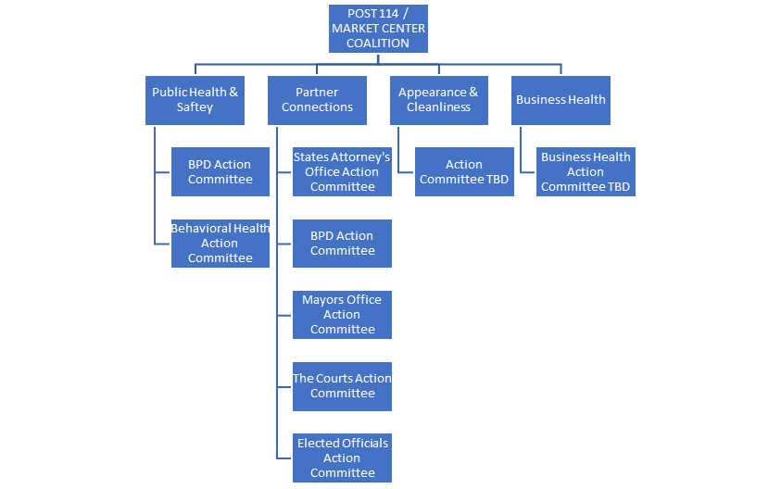
Public Health & Safety
- BPD Action Committee – Participants include Bruce Panczner, Mike Watson, Bill Marcus, Perry Stanfield, Chad Ellis (UMBPD). They are creating an action plan to share with Central District leaders and Commissioner Harrison. They have requested a meeting with Lindsey Eldridge.

- Behavioral Health Action Committee – The group has not met but is making progress:

  - Gwen Brown and Stacey Jefferson with BHSB made recommendations regarding how the Post 114/MC Coalition can help to address substance use and mental health issues in Market Center (reflected on work plan slides 7 and 8). They stressed the need for advocacy for more robust and sustainable funding for mobile crisis teams, peer-to-peer outreach, and harm reduction teams, and to allow Medicaid to cover mobile crisis teams’ responses. Arish Narayen concurred and said that LEAD, which is still operating, also needs funding. They will let us know when specific advocacy opportunities arise.
  - Gwen and Kristen will distribute materials to businesses to advertise the crisis hotline.
  - Nate Fields recommended investigating whether Medicaid can cover the cost of housing for people with frequent needs. Tamika offered to investigate.
  - Ann Winder introduced Bruce Panczner, Kristen Mitchell, Nate Fields, and Kisha Webster (BEAM) to Towanda Taylor, owner of Second Chance Behavioral Health Center, a mental health facility that offers intensive outpatient and outpatient substance abuse, psychiatric rehabilitation services. Nate, Towanda, and Kisha shared contact information, to facilitate referrals. BEAM and Second Chance are working out how to share space at 7 N. Eutaw.
Nate will connect with Arish to facilitate referrals to LEAD. He is seeing a surge of people in need, with increasingly severe cases. He is also connecting People Encouraging People to the people who hang out on the 300-400 blocks of Park Avenue.
Appearance & Cleanliness
Kristen Mitchell reviewed the Appearance & Cleanliness component of the work plan.
A stakeholder group met with Carolyn Mozell, Daniel Ramos, Marianne Navarro, and Tamika Gauvin on July 15 to advocate for city improvements to Market Center’s public realm (specifically lighting and sidewalk improvements the unit-400 blocks of Howard Street and the 100-300 blocks of Eutaw). Kristen will send a letter to Steve Sharkey (DOT Director) to follow up on our request.
Marianne Navarro noted that the Planning Commission is hosting a CIP Information & Listening Session on August 11. Planning staff will present an overview of the CIP process, funding sources and uses, and discuss its approach to analyzing equity in the capital budget. Residents and stakeholders can comment on the CIP. Planning staff and Planning Commissioners will attend to hear public comments.
Business Health
Kristen Mitchell reviewed the Business Health component of the work plan.
Judson Kerr spoke with business owners on the 100 block of Howard. They are resistant to investing currently – they want to see the city address its own vacant buildings on the block.
Kyree West said that BDC is still negotiating with developers on properties in that block (as part of two RFPs that include properties roughly bound by Fayette/Howard/Lexington/Park). He was unable to provide additional information. He is happy to talk with building and business owners about façade improvement grants. The City’s small business grant is out of funds.
Sam Storey reported that DPOB has funds available for façade improvement grants, and he is happy to talk with building and business owners about this, too. DPOB is also working on a program to connect black business owners with available, move-in ready spaces downtown. He has information on available spaces in Market Center.
Shaffin Jethin suggested exploring the possibility of hosting short-term popups at some of the vacant spaces. He asked if we are working on a Covid-related policy to support tenant retention. We will add this to the September agenda.
New Business/Announcements:
- Maryland Stadium Authority is transitioning the stadiums from their temporary healthcare-related uses back to sports.
- DPOB’s Clean & Safe Teams are working. Stephanie Bolton mentioned that they would welcome the ability to get water at businesses while in the district.
- Kevin Hayes drove through the micro zone to identify broken streetlights and streets in poor condition. He forwarded his findings to BGE (lights) and DOT (streets) and will share with the group.
- Nate Fields said that many shelters are shut down due to COVID-19, while others are at capacity. His team is still doing outreach, which has been complicated by COVID-19.

September Meeting Date – Tuesday, 9/8

